**Development of a New Biometric Authentication**

**Approach Based on Electrocardiogram Signals**

**CHAPTER -1**

**ABSTRACT**

Biometrics is one of the greatest ways to authenticate people, according to recent research. This study proposes the electrocardiograph (ECG), a biometric that measures heartbeat. The ECGs are distinctive, hence the heartbeat biometric was chosen. Given the extractions and classification methods for the cardiac biometric signal, the goal of this study is to determine the best biometric features that can be used to identify a certain person. Based on a literature review, we presented a new, more effective method for extracting features from the ECG signal that uses these features as inputs for pattern recognition classifiers. This method is based on wave modelling of the ECG signal. The current approach involves a Median Filtering unlike the existing methods which removed at a greater extent, but not to the desired level, where the detection becomes more accurate. This suggested methodology has been tested on actual experimental ECG data. In order to process ECG signals, the most well-known and versatile MATLAB software must be used for signal acquisition, signal filtering, and pre-processing. When compared to features generated from traditional parameters, the results are quite accurate. In order to achieve the best classification results, wave modelling for feature extraction is the most effective and accurate method. In terms of future work, real-time applications that identify people require automatic heartbeat categorization.

**Keywords:** Biometrics, Electrocardiogram, Heartbeat Recognition, Waves Modeling.

**CHAPTER-2**

**INTRODUCTION**

Today, life engages technology in multiple ways, thus authentication in human technologies is very important. Secure and reliable authentication is in high demand. However, traditional methods for authentication such as face recognition, voice recognition and passwords are now outdated because faces are available in social media and couldn’t differentiate between two twins, and voices can be easily recorded from calls. However, ECG signal is a universal characteristic [1]. The Electrocardiogram (ECG) is the recording of electrical activity of human heart using electrodes placed on the skin over a period of time. The shape of the waveform reveals the current state of the heart and it offers helpful information regarding the rhythm and function of the heart. There are 3 main components to an ECG: P wave, QRS complex and T wave [2]. Recently, the possibility of using this ECG signal as a biometric tool has been suggested because the composition and activity of the human heart is unique, stable, easy to collect, have a high performance and it’s socially accepted. Its validity is well supported by the fact that both the physiological and geometrical differences of the heart under different subjects reveal certain uniqueness in the signal characteristics due to existing differences in morphology among individuals. II. MATERIALS AND METHODS A. DATA ACQUISITION The ECG data used in this research is obtained from real experimental data. The total number of person is 10 subjects recorded over 210 seconds long. The subjects are 6 men aged 20-30 years and 4 women aged 20-25 years. The ECGs were recorded via a commercial ECG device (500 Hz as sampling rate and 500 dB for gain). The number of recordings for each person are obtain from ECG lead 1. In this step signal is being acquired and stored in database, which is further used by system for identification purposes. B. DATA PRE-PROCESSING ECG data collected usually contain noise. Due to presence of noise the feature extraction and classification becomes less accurate. To prevent misclassification, the ECG data must be processed. The first step must be to identify the noisy sources [3]. In this research, a cascaded digital filters configuration (empirical mode decomposition, low pass filter, high pass filter and derivative base filter), as shown in figure 1, is used for removal of three major noises of baseline drift, power line interference and EMG noise

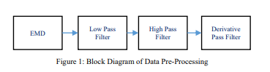

EMD is a decomposition technique that allows to represent a signal through the sum of functions derived from the latter, called Intrinsic Mode Function (IMF). The individual IMFs are obtained through a sifting operation. This is an iterative operation. The basic steps to achieve decomposition in IMF are: a. Identify local extremes. Especially, the maximum and minimum local values of the signal must be evaluated separately. b. Evaluate the upper and lower envelope of the signal through the application of a cubic spline EMD Low Pass Filter High Pass Filter Derivative Pass Filter 2019 Fifth International Conference on Advances in Biomedical Engineering (ICABME) 978-1-7281-2314-1/19/$31.00 ©2019 IEEE interpolation function of the data obtained in the previous point. c. Compute the mean envelope, obtaining m. Then subtract the mean from the input signal. d. Evaluate a term condition. If this is respected, then the difference between the input signal and m is the IMF and the next one is evaluated considering as a signal the difference between the input one and the IMF obtained. Otherwise, the process on the residual is repeated [4] . Figure 2 shows a block diagram of the algorithm of EMD

**CHAPTER-3**

**LITERATURE REVIEW**

**[1] Ala Abdulhakim Alariki, Sayed Mahmoud Alavy, Mohammad Reza Yousufi, Mohammad Tareq Aziz and Christine Murray, A Review Study of Heartbeat Biometric Authentication, Volume 13, Number 8, August 2018**

Today, life engages technology in multiple ways, thus authentication in human technologies is very important. Secure and reliable authentication is in high demand. However, traditional methods for authentication such as passwords and tokens are now outdated because it is possible to steal, lose and share such authentication methods. Current research shows that one of the best methods for authenticating human beings is biometrics. In this paper, the heartbeat biometric, also called Electrocardiographic (ECG), is proposed. The heartbeat biometric is chosen because unique human ECGs cannot be falsely created or replicated. While other biometric methods, such as face recognition, can be compromised by user photographs, or fingerprints, which can be compromised by use of fake fingers, the ECG signal is based on the individualized mechanical movements of each human heart, which features contain unique physiological information. The purpose of this paper is, then, to review various relevant, recent works that study the heartbeat biometric to find the best biometrics features, given the extractions and classification algorithms for the heartbeat biometric signal. This paper concludes that the morphological (P wave) feature is recommended as the most important feature and the Neural Network (NN) classifier is the most reliable classification with the highest performance accuracy for heartbeat biometric. Therefore, to achieve highest accuracy and result for authenticating through heartbeat biometric, it is recommended to consider the mentioned feature extractions and classification

**Summary**: Studied about A Review Study of Heartbeat Biometric Authentication

**[2] Kiran KumarPatro and P. RajeshKumar****, Effective Feature Extraction of ECG for Biometric Application, Procedia Computer Science, Volume 115, 2017, Pages 296-306** Biometric systems performing identity recognition based upon extracted informative data from an individual are vital for security applications. The vital characteristics of an ECG signal depend upon its Characteristic points’ P, Q, R, S and T. In this paper, an effective feature extraction method is proposed, in which for each record of ECG, the best 6-PQRST fragments are extracted according to priority basis and their positions are normalized. A total of 72 different features are calculated, finally the performance of feature set is examined and compared using ANN. The proposed algorithm is tested for MIT-BIH ECG ID database signals.

**Summary:** Studied the **,** Effective Feature Extraction of ECG for Biometric Application.

**[3] Gaganpreet Kaur, Dr. Dheerendra Singh and Simranjeet Kaur****, Electrocardiogram (ECG) as a Biometric Characteristic: A Review, International Journal of Emerging Research in Management &Technology ISSN: 2278-9359 (Volume-4, Issue-5)**

**.** In recent decade, the number of system uses biometric system for authentication. There were several biometric systems present based on external physiological characteristics such as face, iris, fingerprint, palm print etc. but few researchers worked on the internal physiological characteristics as a biometric. This project includes the design of an ECG-based biometric system that uses machine learning and deep learning techniques. ECG contains detailed information about electrical operation of the heart and the nature of this activity is highly personalized and can be used as biometric for authentication purpose. ECG based biometric can be mainly used in IOT based health care systems where data is transferred on internet. Other biometric systems require extra hardware to be used in health care systems. As ECG of a patient is taken in the hospitals, the same can be used for identification without extra hardware. Interval features of ECG signal are extracted and given to machine learning and deep learning algorithms. Machine learning techniques like SVM and KNN are used and deep learning is based on CNN. The datasets with diverse ECG behaviors are considered including MITDB, FANTASIA, NSRDB and QT. These datasets are collected from healthy or near-healthy participants and some include heart diseases such as arrhythmia and atrial fibrillation. The proposed CNN based approach achieved an accuracy of 81.33%, 96.95%, 94.73% and 92.85% on MITDB, FANTASIA, NSRDB and QT database respectively.

**Summary:** Investigated , Electrocardiogram (ECG) as a Biometric Characteristic

**[4] Rupert Faltermeier, Ingo R. Keck, Ana Maria Tomé and Carlos G. Puntonet, Empirical Mode Decomposition - An Introduction, July 2010, DOI: 10.1109/IJCNN.2010.5596829**

Traditional mobile login methods, like numerical or graphical passwords, are vulnerable to passive attacks. It is common for intruders to gain access to personal information of their victims by watching them enter their passwords into their mobile screens from a close proximity. With this in mind, a mobile biometric authentication algorithm based on electrocardiogram (ECG) is proposed. With this algorithm, the user will only need to touch two ECG electrodes (lead I) of the mobile device to gain access. The algorithm was tested with a cell phone case heart monitor in a controlled laboratory experiment at different times and conditions with ten subjects and also with 73 records obtained from the Physionet database. The obtained results reveal that our algorithm has 1.41% false acceptance rate and 81.82% true acceptance rate with 4 s of signal acquisition. To the best of our knowledge, this is the first approach on mobile authentication that uses ECG biometric signals and it shows a promising future for this technology. Nonetheless, further improvements are still needed to optimize accuracy while maintaining a short acquisition time for authentication.

Summary: Studied ECG authentication for mobile devices.

**[5] Shweta H. Jambukia, Vipul K. Dabhi and Harshadkumar B. Prajapati, Classification of ECG signals using Machine Learning Techniques a Survey, 978-1-4673- 6911-415,2015**

Classification of electrocardiogram (ECG) signals plays an important role in diagnoses of heart diseases. An accurate ECG classification is a challenging problem. This paper presents a survey of ECG classification into arrhythmia types. Early and accurate detection of arrhythmia types is important in detecting heart diseases and choosing appropriate treatment for a patient. Different classifiers are available for ECG classification. Amongst all classifiers, artificial neural networks (ANNs) have become very popular and most widely used for ECG classification. This paper discusses the issues involved in ECG classification and presents a detailed survey of preprocessing techniques, ECG databases, feature extraction techniques, ANN based classifiers, and performance measures to address the mentioned issues. Furthermore, for each surveyed paper, our paper also presents detailed analysis of input beat selection and output of the classifiers..

**Summary:** Studied Classification of ECG signals using Machine Learning Techniques.

**CHAPTER-4**

**EXISTING METHOD**

After demonizing the signal, the data is then divided into train and test sets as shown in figure 5: i. In training phase: 70% of the filtered data is used as the training samples for classification. ii. In testing phase: 30% of the filtered data is use as testing data for validation.

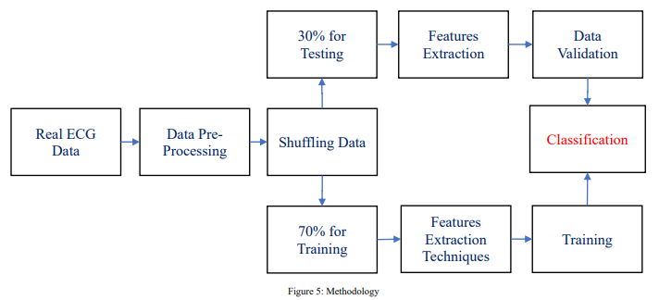

FEATURE EXTRACTION The feature extraction stage is the key to the success in the heartbeat classification using in the ECG signal. The feature can be extracted in various form directly from the ECG signal’s morphology in the time domain and/or in the frequency domain or from the cardiac rhythm.

1) Peak detection: The third step is detection of peaks locations and boundaries of three types of waves, P wave, QRS complex, and T wave which are used in heartbeat signals [1] . Generally, in ECG, the major characteristic wave is R-peak because it has the higher amplitude. After finding R-peak location, other components P, Q, S, and T are detected by taking R-peak location as reference and tracing from R peak relative position

2) Segmentation: After identifying the points, ECG waveform is segmented into individual heartbeat, as shown in figure 8, and decomposed as a form of sine wave

3) Wave Modeling: The purpose of the feature extraction is to have identical model from same user and different model from different users. This is one of the main step of biometric heart beat because a vector features will be composed and extracted from heartbeat signals as input. We use “cftool” in Matlab to choose the best model of curve fitting and then we generate the code. (1) shows the general model of sum of sine method with degree 5 that is used for modeling.

B. BIOMETRIC TEMPLATE IN DATABASE In this step, the vector features of each individual is stored in database. Then the stored data is compared with the entered data from testing phase to identify person for decision making [1].

IV.CLASSIFICATION Classification is used to classify entered data in different set of classes that would be easy to compare with stored data. There are different methods for classification [1] . In this study, the biometric identification is done by feeding the input data of ECG features to an Artificial Neural Network (ANN) [6] . At the primary stage the neural network has to be trained with the ECG data of different persons. Then afterwards the neural network generated from the training is used for biometric identification of the persons. Figure 10 shows the architecture of neural network that is composed by features as an input, hidden layers and output that identify the person.

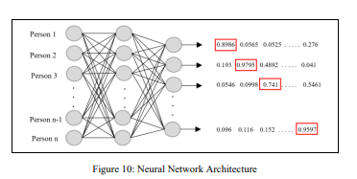

**DISADVANTAGES:**

1. Shift-Sensitivity

2. Unpredictable change in the output coefficients

3. Poor directional selectivity

5. Lack of Directionality

6.Alasing

**CHAPTER-5**

**PROPOSED METHOD**



The data is then split into train and test sets after the signal has been demonised, as seen in figure 5: i. For the classification training samples, 70% of the filtered data is used in the training phase. ii. 30% of the filtered data are used as testing data for validation throughout the testing phase.

**FEATURE EXTRACTION**, Part A The success of the heartbeat classification process utilising the ECG signal is dependent on the feature extraction stage. The characteristic can be directly retrieved in a number of ways from the heart rhythm or from the time- or frequency-domain morphology of the ECG signal.

**B. 1) Peak detection:** The third step is the identification of the peaks and boundaries of the three wave types employed in heartbeat signals—P wave, QRS complex, and T wave. R-peak typically serves as the main characteristic wave in an ECG because of its higher amplitude. By using the R-peak location as a reference and tracing from the R peak relative position after determining the R-peak location, other components P, Q, S, and T are identified.

**Median filter**

* The median filter is a non-linear digital filtering technique, often used to remove noise from an image or signal. Such noise reduction is a typical pre-processing step to improve the results of later processing (for example, edge detection on an image). Median filtering is very widely used in digital image processing because, under certain conditions, it preserves edges while removing noise (but see the discussion below), also having applications in signal processing.

**Algorithm**

The main idea of the median filter is to run through the signal entry by entry, replacing each entry with the median of neighbouring entries. The pattern of neighbours is called the "window", which slides, entry by entry, over the entire signal. For one-dimensional signals, the most obvious window is just the first few preceding and following entries, whereas for two-dimensional (or higher-dimensional) data the window must include all entries within a given radius or ellipsoidal region (i.e. the median filter is not a separable filter).

**Example**

To demonstrate, using a window size of three with one entry immediately preceding and following each entry, a median filter will be applied to the following simple one-dimensional signal:

x = (2, 3, 80, 6, 2, 3).

So, the median filtered output signal y will be:

y1 = med(2, 3, 80) = 3, (already 2, 3, and 80 are in the increasing order so no need to arrange them)

y2 = med(3, 80, 6) = med(3, 6, 80) = 6, (3, 80, and 6 are rearranged to find the median)

y3 = med(80, 6, 2) = med(2, 6, 80) = 6,

y4 = med(6, 2, 3) = med(2, 3, 6) = 3,

i.e. y = (3, 6, 6, 3).

2) Segmentation: After identifying the points, ECG waveform is segmented into individual heartbeat, as shown in figure 8, and decomposed as a form of sine wave

3) Wave Modeling: The purpose of the feature extraction is to have identical model from same user and different model from different users. This is one of the main step of biometric heart beat because a vector features will be composed and extracted from heartbeat signals as input. We use “cftool” in Matlab to choose the best model of curve fitting and then we generate the code. (1) shows the general model of sum of sine method with degree 5 that is used for modeling.

B. BIOMETRIC TEMPLATE IN DATABASE In this step, the vector features of each individual is stored in database. Then the stored data is compared with the entered data from testing phase to identify person for decision making [1].

IV.CLASSIFICATION Classification is used to classify entered data in different set of classes that would be easy to compare with stored data. There are different methods for classification [1] . In this study, the biometric identification is done by feeding the input data of ECG features to an Artificial Neural Network (ANN) [6] . At the primary stage the neural network has to be trained with the ECG data of different persons. Then afterwards the neural network generated from the training is used for biometric identification of the persons. Figure 10 shows the architecture of neural network that is composed by features as an input, hidden layers and output that identify the person.



**CHAPTER-6**

**ADVANTAGES AND APPLICATIONS**

**Advantages:**

1. High Accuracy than the existing method
2. Unique and Non-Replicable
3. Non-invasive
4. Robustness
5. Cost-effective
6. Improved Security

**Applications:**

Healthcare

Fitness Tracking

Authentication for Secure Systems

Military and Law Enforcement

**CHAPTER-7**

**MATLAB**

**7.1 INTRODUCTION TO MATLAB**

**What Is MATLAB?**

MATLAB is an elite dialect for specialized registering. It incorporates calculation, representation, and programming in an easy to-utilize condition wherein issues and preparations are communicated in herbal numerical documentation. Run of the mill utilizes comprise

• Math and calculation

• Algorithm advancement

• Data obtaining

• Modeling, re-enactment, and prototyping

• Data examination, investigation, and representation

• Scientific and designing illustrations

• Application advancement, including graphical UI building

MATLAB is an intuitive framework whose important statistics aspect is an show off that does not require dimensioning. This allows you to tackle several specialized processing issues, particularly those with framework and vector info, in a small quantity of the time it'd take to compose a program in a scalar non intuitive dialect, as an instance, C or FORTRAN.

The call MATLAB stays for grid studies facility. MATLAB changed into first of all composed to present easy access to framework programming created by way of the LINPACK and EISPACK ventures. Today, MATLAB motors fuse the LAPACK and BLAS libraries, inserting the cutting side in programming for network calculation.

MATLAB has advanced over a time of years with contribution from several customers. In university situations, it's far the usual academic apparatus for early on and propelled guides in mathematics, designing, and science. In enterprise, MATLAB is the tool of choice for excessive-profitability studies, advancement, and exam.

MATLAB highlights a collection of more utility-specific arrangements known as tool booths. Important to most clients of MATLAB, device kits permit you to learnandapply particular innovation. Tool compartments are exhaustive accumulations of MATLAB capacities (M-records) that reach out the MATLAB condition to take care of precise training of problems. Territories in which tool stash are reachable include flag coping with, manipulate frameworks, neural structures, fluffy reason, wavelets, pastime, and severa others.

**The MATLAB System:**

The MATLAB system consists of five main parts.

**Development Environment:**

 This is the set of tools and centres that help you operate MATLAB features and files. Many of that gear are graphical person interfaces. It includes the MATLAB desktop and Command Window, a command history, an editor and debugger, and browsers for viewing assist, the workspace, files, and the hunt direction.

**The MATLAB Mathematical Function:**

This is a great collection of computational algorithms ranging from standard capabilities like sum, sine, cosine, and complex arithmetic, to extra sophisticated features like matrix inverse, matrix eigen values, Bessel functions, and speedy Fourier transforms.

**The MATLAB Language:**

This is a high-level matrix/array language with control flow statements, functions, data structures, input/output, and object-oriented programming features. It allows both "programming in the small" to rapidly create quick and dirty throw-away programs, and "programming in the large" to create complete large and complex application programs.

**Graphics:**

MATLAB has considerable centres for displaying vectors and matrices as graphs, as well as annotating and printing those graphs. It consists of high-stage functions for 2-dimensional and 3-dimensional records visualization, photograph processing, animation, and presentation graphics. It also consists of low-stage capabilities that will let you absolutely customise the appearance of graphics as well as to construct complete graphical person interfaces for your MATLAB programs.

**The MATLAB Application Program Interface (API):**

This is a library that allows you to put in writing C and Fortran applications that have interaction with MATLAB. It consists of facilities for calling workouts from MATLAB (dynamic linking), calling MATLAB as a computational engine, and for studying and writing MAT-documents.

**7.2 MATLAB WORKING ENVIRONMENT:**

## MATLAB DESKTOP:

Matlab Desktop is the principle Matlab application window. The desktop consists of five sub windows, the summon window, the workspace program, the existing catalog window, the order records window, and at the least one figure home windows, which can be proven simply while the consumer suggests a sensible.

The order window is the area the customer sorts MATLAB orders and expressions at the initiate (>>) and wherein the yield of these fees is shown. MATLAB characterizes the workspace because the association of factors that the customer makes in a work session. The workspace software demonstrates these elements and some statistics approximately them. Double tapping on a variable within the workspace application dispatches the Array Editor, which may be applied to get data and salary instances modify sure homes of the variable.

The present Directory tab over the workspace tab demonstrates the substance of the existing registry, whose way is seemed within the present index window. 1For case, within the windows running framework the manner may be as consistent with the subsequent: C:MATLABWork, demonstrating that registry "paintings" is a subdirectory of the primary catalog "MATLAB", which is delivered in pressure C. Tapping on the bolt inside the present index window demonstrates a rundown of as of past due utilized approaches. Tapping at the seize to one aspect of the window enables the client to exchange the existing catalog.

MATLAB utilizes an inquiry way to discover M-data and different MATLAB related documents, which might be sort out in catalogs within the PC file framework. Any file keep strolling in MATLAB must dwell inside the ebb and go with the flow registry or in an index that is on are trying to find manner. Of direction, the statistics supplied with MATLAB and math works device kits are included into the inquiry way. The least stressful method to look which indexes are at the inquiry manner. The handiest method to peer which catalogs are soon the quest way, or to encompass or regulate an inquiry manner, is to pick set manner from the File menu the computer, and after that utilization the set way exchange container. It is exquisite exercise to add any typically utilized catalogs to the pursuit way to hold a strategic distance from again and again having the exchange the existing index.

The Command History Window contains a record of the orders a client has entered in the charge window, including both present and past MATLAB sessions. Already entered MATLAB orders can be chosen and re-executed from the charge history window by right

tapping on a summon or arrangement of orders. This activity dispatches a menu from which to choose different choices notwithstanding executing the orders. This is helpful to choose different choices notwithstanding executing the summons. This is a valuable component while trying different things with different orders in a work session

**Using the MATLAB Editor to create M-Files:**

The MATLAB manager is both a word processor unique for making M-statistics and a graphical MATLAB debugger. The proofreader can display up in a window without everybody else, or it could be a sub window in the laptop. M-facts are intended by means of the expansion .M, as in pixelup.M. The MATLAB editorial manager window has various draw down menus for errands, for instance, sparing, seeing, and troubleshooting documents. Since it plays out a few basic checks and furthermore utilizes shading to separate between exclusive additives of code, this content device is suggested as the equipment of selection for composing and changing M-capacities. To open the proofreader, sort regulate at the incite opens the M-report filename.M in a supervisor window, organized for altering. As referred to before, the record has to be inside the momentum catalog, or in an index within the pursuit manner.

**Getting Help:**

The important technique to get help on line is to utilize the MATLAB assist application, opened as a exclusive window both via tapping at the query mark image at the computing device toolbar, or by using writing help program on the provoke within the order window. The help Browser is an internet application coordinated into the MATLAB computing device that shows a Hypertext Markup Language (HTML) statistics. The Help Browser contains of two sheets, the assistance pilot sheet, used to find out data, and the show sheet, used to look the statistics. Clear as crystal tabs aside from pilot sheet are applied to play out a pursuit. Second, within the motion pictures taken via transferring camera setup, the state of affairs becomes extra complex because the heritage may additionally exchange by using shifting shot, we cannot tune item motion exactly inside the sum of distinction map. Therefore, in this situation, the purpose is executed through reusing the previous seam and applying it to the cutting-edge body. In order to discover the seams, we use the preceding seam from previous body to look the modern-day seam in contemporary frame. our method is using a seam computed in frame1 (in crimson) to go looking a comparable seam in frame2. For the pixels close by the area of previous seam, we decide how a lot the selected pixel might vary from the pixel of preceding seam. We use difference of the 2 pixels as the degree of temporal coherence. If the distinction value of first seam pixel is over the threshold, we can keep to go looking the next seam pixel on three feasible pixels (in yellow, blue and brown) in subsequent row, until we discover 5 consecutive pixels that also exceed the threshold.

When we can't search the matching seam, we recalculate the energy for a new seam. We assume a seam 𝑆l-1 has been calculated inside the previous body, and a seam must be calculated for the contemporary frame. For preserving the temporal coherence, we want to make a new seam close to the previous seam with the identical index. We use the distinction among preceding seam and all pixels at the current body as the measure

Thus we upload temporal coherence price Tc(i,j) to the strength map earlier than calculating a seam 𝑆L. The price Tc is zero while the body pixels have the equal fee as previous seam pixels. Using our temporal coherence price, we will calculate the seam which has least electricity and is more close to the preceding seam in previous frame. Consequently, we will decrease the jittery artifacts inside the films.

**COMMUNICATION:**

Communications System Toolbox™ offers algorithms and gear for the layout, simulation, and analysis of communications systems. These capabilities are furnished as MATLAB ® features, MATLAB System gadgets™, and Simulink ® blocks. The machine toolbox includes algorithms for source coding, channel coding, interleaving, modulation, equalization, synchronization, and channel modeling. Tools are supplied for bit blunders charge evaluation, producing eye and constellation diagrams, and visualizing channel characteristics. The machine toolbox additionally provides adaptive algorithms that allow you to version dynamic communications structures that use OFDM, OFDMA, and MIMO techniques. Algorithms support fixed-point facts arithmetic and C or HDL code era.

**Key Features**

▪ Algorithms for designing the physical layer of communications systems, which includes supply coding, channel coding, interleaving, modulation, channel fashions, MIMO, equalization, and synchronization

▪ GPU-enabled System objects for computationally intensive algorithms together with Turbo, LDPC, and Viterbi decoders

▪ Interactive visualization equipment, consisting of eye diagrams, constellations, and channel scattering capabilities

▪ Graphical tool for evaluating the simulated bit mistakes rate of a machine with analytical outcomes

▪ Channel models, consisting of AWGN, Multipath Rayleigh Fading, Rician Fading, MIMO Multipath Fading, and

LTE MIMO Multipath Fading

▪ Basic RF impairments, along with nonlinearity, section noise, thermal noise, and section and frequency offsets

▪ Algorithms available as MATLAB features, MATLAB System objects, and Simulink blocks

▪ Support for fixed-point modeling and C and HDL code technology

**System Design, Characterization, and Visualization:**

The layout and simulation of a communications gadget requires analyzing its reaction to the noise and interference inherent in real-world environments, reading its behavior the usage of graphical and quantitative manner, and determining whether the resulting overall performance meets requirements of acceptability. Communications System Toolbox implements a selection of obligations for communications machine layout and simulation. Many of the functions, System objects™, and blocks inside the device toolbox perform computations associated with a specific thing of a communications gadget, consisting of a demodulator or equalizer. Other talents are designed for visualization or evaluation.

**System Characterization**

The system toolbox offers several standard methods for quantitatively characterizing system performance:

▪ Bit error rate (BER) computations

▪ Adjacent channel power ratio (ACPR) measurements

▪ Error vector magnitude (EVM) measurements

▪ Modulation error ratio (MER) measurements

Because BER computations are fundamental to the characterization of any communications system, the system toolbox provides the following tools and capabilities for configuring BER test scenarios and accelerating BER simulations:

**BER tool**— A graphical user interface that enables you to analyze BER performance of communications systems. You can analyze performance via a simulation-based, semi analytic, or theoretical approach.

**Error Rate Test Console** — A MATLAB object that runs simulations for communications systems to measure error rate performance. It supports user-specified test points and generation of parametric performance plots and surfaces. Accelerated performance can be realized when running on a multi core computing platform.

**Multi core and GPU acceleration** — A capability provided by Parallel Computing Toolbox™ that enables you to accelerate simulation performance using multi core and GPU hardware within your computer.

**Distributed computing and cloud computing support** — Capabilities provided by Parallel Computing Toolbox and MATLAB Distributed Computing Server™ that enable you to leverage the computing power of your server farms and the Amazon EC2 Web service. Performance Visualization. The system toolbox provides the following capabilities for visualizing system performance:

**Channel visualization tool** — For visualizing the characteristics of a fading channel

**Eye diagrams and signal constellation scatter plots** — for a qualitative, visual understanding of system behavior that enables you to make initial design decisions

**Signal trajectory plots** — for a continuous picture of the signal’s trajectory between decision points

**BER plots** — for visualizing quantitative BER performance of a design candidate, parameterized by metrics such as SNR and fixed-point word size

**Analog and Digital Modulation**

Analog and digital modulation strategies encode the facts circulation into a sign this is appropriate for transmission. Communications System Toolbox presents some of modulation and corresponding demodulation abilities. These talents are available as MATLAB features and gadgets, MATLAB System Modulation sorts provided by the toolbox are:

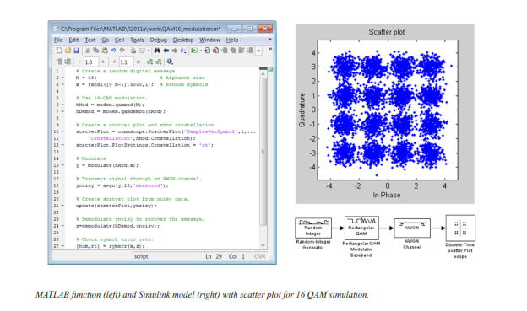**Source and Channel Coding**

Communications System Toolbox affords source and channel coding talents that can help you develop and compare communications architectures fast, enabling you to discover what-if eventualities and avoid the need to create coding competencies from scratch.

**Source Coding**

Source coding, also referred to as quantization or signal formatting, is a manner of processing facts a good way to lessen redundancy or prepare it for later processing. The system toolbox offers a diffusion of styles of algorithms for imposing source coding and interpreting, inclusive of:

▪ Quantizing

▪ Companding (*µ*-law and A-law)

▪ Differential pulse code modulation (DPCM)

▪ Huffman coding

▪ Arithmetic coding

**Channel Coding**

▪ orthogonal area-time block code (OSTBC) (encoder and decoder for MIMO channels)

▪ Turbo encoder and decoder examples

The gadget toolbox offers application functions for developing your personal channel coding. You can create generator polynomials and coefficients and syndrome deciphering tables, in addition to product parity-take a look at and generator matrices.

The system toolbox additionally presents block and convolutional interleaving and deinters leaving functions to reduce facts errors as a result of burst mistakes in a conversation machine:

**Block,** including General block interleaver, algebraic interleaver, helical scan interleaver, matrix interleaver, and random interleaver.

**Convolutional,** including General multiplexed interleaver, convolutional interleaver, and helical interleaver

**Channel Modeling and RF Impairments**

Channel Modeling

Communications System Toolbox provides algorithms and tools for modeling noise, fading, interference, and different distortions which might be commonly found in communications channels. The system toolbox supports the subsequent styles of channels:

▪ Additive white Gaussian noise (AWGN)

▪ Multiple-enter multiple-output (MIMO) fading

▪ Single-enter single-output (SISO), Rayleigh, and Rician fading

▪ Binary symmetric

A MATLAB channel object provides a concise, configurable implementation of channel models, enabling you to

specify parameters such as:

▪ Path delays

▪ Average path gains

▪ Maximum Doppler shifts

▪ K-Factor for Rician fading channels

▪ Doppler spectrum parameters

For MIMO systems, the MATLAB MIMO channel object expands these parameters to also include:

▪ Number of transmit antennas (up to 8)

▪ Number of receive antennas (up to 8)

▪ Transmit correlation matrix

▪ Receive correlation matrix

To combat the effects noise and channel corruption, the system toolbox provides block and convolutional coding and decoding techniques to implement error detection and correction. For simple error detection with no inherent correction, a cyclic redundancy check capability is also available. Channel coding capabilities provided by the system toolbox include:

▪ BCH encoder and decoder

▪ Reed-Solomon encoder and decoder

▪ LDPC encoder and decoder

▪ Convolutional encoder and Viterbi decoder

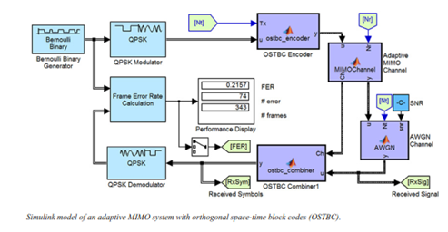

**RF Impairments**

To model the effects of a non-ideal RF front end, you can introduce the following impairments into your communications system, enabling you to explore and characterize performance with real-world effects:

▪ Memory less nonlinearity

▪ Phase and frequency offset

▪ Phase noise

▪ Thermal noise

You can include more complex RF impairments and RF circuit models in your design using SimRF™.

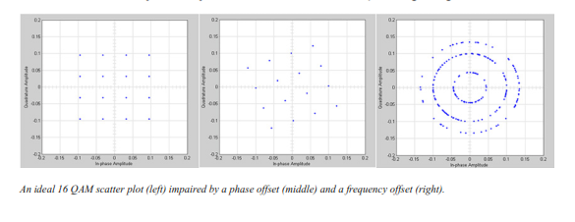

**Equalization and Synchronization**

Communications System Toolbox lets you discover equalization and synchronization strategies. These techniques are usually adaptive in nature and tough to design and symbolize. The machine toolbox affords algorithms and tools that will let you swiftly select the proper approach on your communications machine. Equalization To compare one-of-a-kind techniques to equalization, the device toolbox offers you with adaptive algorithms which include:

▪ LMS

▪ Normalized LMS

▪ Variable step LMS

▪ Signed LMS

▪ MLSE (Viterbi)

▪ RLS

▪ CMA

These adaptive equalizers are available as nonlinear decision feedback equalizer (DFE) implementations and as

Linear (symbol or fractionally spaced) equalizer implementations.

**Synchronization**

The device toolbox provides algorithms for each service segment synchronization and timing phase synchronization. For timing section synchronization, the machine toolbox presents a MATLAB Timing Phase Synchronizer object that offers the following implementation techniques:

▪ Early-late gate timing method

▪ Gardner’s method

▪ Fourth-order nonlinearity method

**Stream Processing in MATLAB and Simulink**

Most verbal exchange structures cope with streaming and frame-primarily based statistics using a aggregate of temporal processing and simultaneous multi frequency and multichannel processing. This form of streaming multidimensional processing can be visible in superior communication architectures consisting of OFDM and MIMO. Communications System Toolbox enables the simulation of advanced communications structures via helping move processing and frame-based simulation in MATLAB and Simulink. In MATLAB, circulate processing is enabled by way of System items™, which use MATLAB objects to symbolize time-based and facts-driven algorithms, sources, and sinks. System objects implicitly manipulate many information of flow processing, including information indexing, buffering, and management of set of rules state. You can mix System gadgets with fashionable MATLAB functions and operators. Most System items have a corresponding Simulink block with the identical abilities. Simulink handles circulation processing implicitly with the aid of coping with the float of information thru the blocks that make up a Simulink model. Simulink is an interactive graphical environment for modeling and simulating dynamic systems that uses hierarchical diagrams to symbolize a machine version. It includes a library of widespread-reason, predefined blocks to represent algorithms, resources, sinks, and device hierarchy.

**Implementing a Communications System**

Fixed-Point Modeling Many communications systems use hardware that requires a fixed-point representation of your design.

Communications System Toolbox supports fixed-point modeling in all relevant blocks and System objects™ with tools that help you configure fixed-point attributes.

Fixed-point support in the system toolbox includes:

▪ Word sizes from 1 to 128 bits

▪ Arbitrary binary-point placement

▪ Overflow handling methods (wrap or saturation)

▪ Rounding methods: ceiling, convergent, floor, nearest, round, simplest, and zero

Fixed-Point Tool in Simulink Fixed Point™ facilitates the conversion of floating-point data types to fixed point. For configuration of fixed-point properties, the tool tracks overflows and maxima and minima.

**Code Generation**

Once you've got advanced your set of rules or communications device, you can robotically generate C code from it for verification, rapid prototyping, and implementation. Most System gadgets, functions, and blocks in Communications System Toolbox can generate ANSI/ISO C code the use of MATLAB Coder™, Simulink Coder™, or Embedded Coder™. A subset of System gadgets and Simulink blocks also can generate HDL code. To leverage present highbrow belongings, you can choose optimizations for specific processor architectures and integrate legacy C code with the generated code.

You can also generate C code for both floating-point and fixed-point data types.

DSP Proto typing DSPs are used in communication system implementation for verification, rapid prototyping, or final hardware implementation. Using the processor-in-the-loop (PIL) simulation capability found in Embedded Coder, you can verify generated source code and compiled code by running your algorithm’s implementation code on a target processor. FPGA Prototyping

FPGAs are used in communication systems for implementing high-speed signal processing algorithms. Using the FPGA-in-the-loop (FIL) capability found in HDL Verifier™, you can test RTL code in real hardware for any existing HDL code, either manually written or automatically generated HDL code.

**CHAPTER -8**

**HARDWARE & SOFTWARE REQUIREMENTS:**

**Software:**

• Matlab R2018a.

**Hardware:**

**Operating Systems:**

• Windows 10

• Windows 7 Service Pack 1

• Windows Server 2019

• Windows Server 2016

**Processors:**

Minimum: Any Intel or AMD x86-64 processor

Recommended: Any Intel or AMD x86-64 processor with four logical cores and AVX2 instruction set support

**Disk:**

Minimum: 2.9 GB of HDD space for MATLAB only, 5-8 GB for a typical installation

Recommended: An SSD is recommended a full installation of all Math Works products may take up to 29 GB of disk space

**RAM:**

Minimum: 4 GB

Recommended: 8

**CHAPTER-9**

**RESULTS**

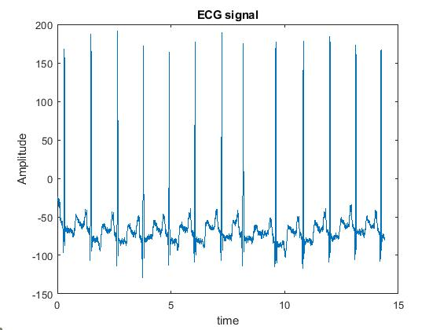

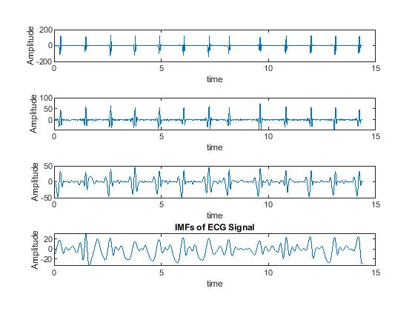

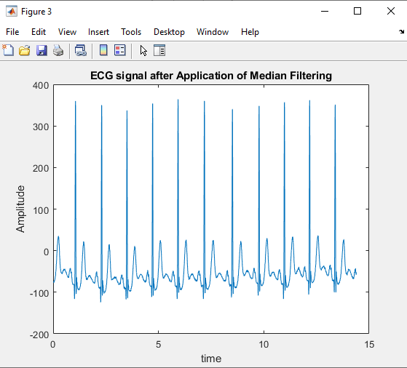

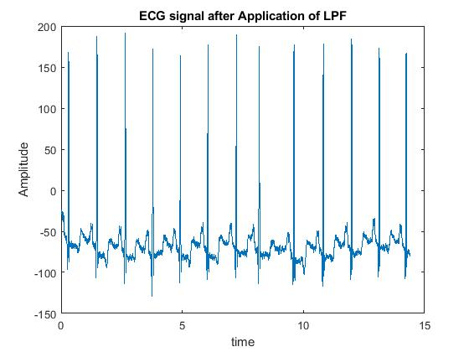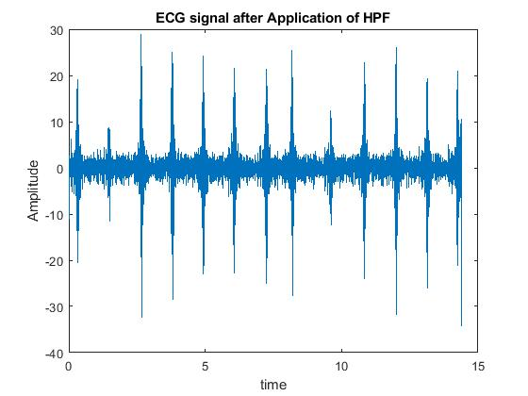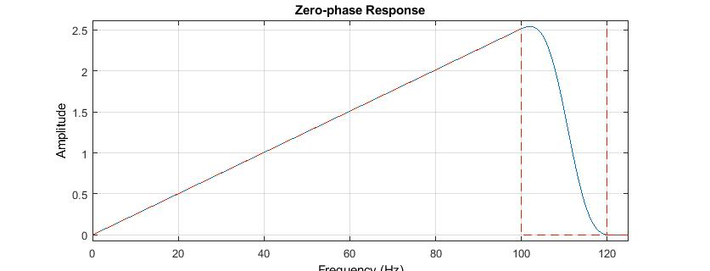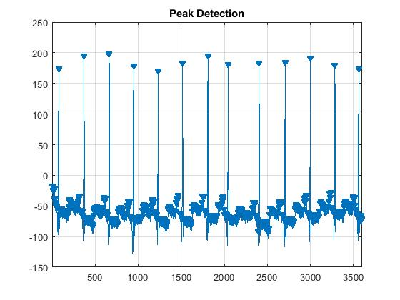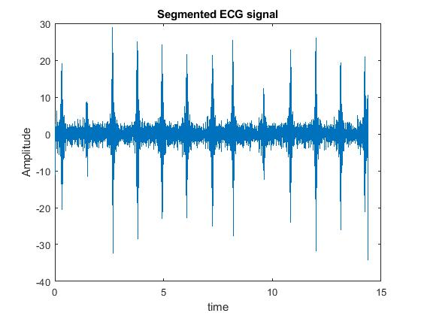

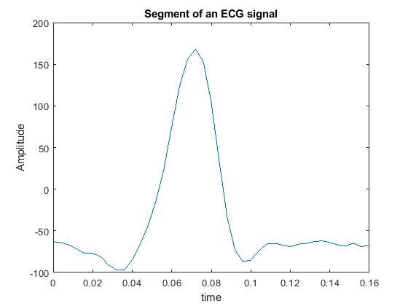

**CHAPTER-10**

**CONCLUSION**

ECG being none mimic able can more accurately identify a person and can offer more robust and effective human identification system. In order to provide more accuracy in identification and verification process of individual, this paper provides an overview of major steps in ECG signal analysis of de-noising ECG, characteristic points identification, feature extraction and effective feature extraction finally classification. The review recognized different methods of extracting features of the heartbeat signals and compared based on the accuracy result. A good feature extraction methodology can accurately work for biometric applications. Automatic heartbeat classification is essential for real-time applications to identify person. The obtained results of this research suggest that there is a possibility growth of future in automatic ECG classification systems. Therefore, the heartbeat biometric system compares the information which is collected after Data Acquisition, Pre-Processing, Segmentation, Feature Extraction, and classification steps with data in storage to make the final decision. Then the system will accept or deny individual

**CHAPTER-11**

**REFERENCES**

[1] Ala Abdulhakim Alariki, Sayed Mahmoud Alavy, Mohammad Reza Yousufi, Mohammad Tareq Aziz and Christine Murray, A Review Study of Heartbeat Biometric Authentication, Volume 13, Number 8, August 2018

[2] Kiran KumarPatro and P. RajeshKumar, Effective Feature Extraction of ECG for Biometric Application, Procedia Computer Science, Volume 115, 2017, Pages 296-306

[3] Gaganpreet Kaur, Dr. Dheerendra Singh and Simranjeet Kaur, Electrocardiogram (ECG) as a Biometric Characteristic: A Review, International Journal of Emerging Research in Management &Technology ISSN: 2278-9359 (Volume-4, Issue-5)

[4] Rupert Faltermeier, Ingo R. Keck, Ana Maria Tomé and Carlos G. Puntonet, Empirical Mode Decomposition - An Introduction, July 2010, DOI: 10.1109/IJCNN.2010.5596829

[5] Shweta H. Jambukia, Vipul K. Dabhi and Harshadkumar B. Prajapati, Classification of ECG signals using Machine Learning Techniques a Survey, 978-1-4673- 6911-415,2015 [6] Alaa Daher, Ghaleb Hoblos, Yahya Chetouani, Mohamad Khalil, modified fuzzy c-means combined with Neural Network based Fault Diagnosis Approach for a distillation column, IEEE International Multidisciplinary Conference on Engineering Technology (IMCET), 2016